A TECHNICAL REPORT ON STUENTS INDUSTRIAL WORK EXPERIENCE SCHEME (SIWES)

COVER PAGE

AT

BENUE LINKS NIGERIA LIMITED,
MAKURDI, BENUE STATE

FROM: 06TH OCTOBER, 2023
TO: 29TH JANUARY, 2024

BY

ADIMAMMUO CHIAGOZIE GERALD
ET/ME/ND/22/055

DEPARTMENT OF MECHANICAL ENGINEERING TECHNOLOGY FEDERAL POLYTECHNIC, MUBI.

JULY, 2024.

A TECHNICAL REPORT ON STUENTS INDUSTRIAL WORK EXPERIENCE SCHEME (SIWES)

TITLE PAGE
AT

BENUE LINKS NIGERIA LIMITED,
MAKURDI, BENUE STATE

FROM: 06TH OCTOBER, 2023
TO: 29TH JANUARY, 2024

BY

ADIMAMMUO CHIAGOZIE GERALD
ET/ME/ND/22/055

DEPARTMENT OF MECHANICAL ENGINEERING TECHNOLOGY FEDERAL POLYTECHNIC, MUBI.

THIS TECHNICAL REPORT IS SUBMITTED TO THE DEPARTMENT OF MECHANICAL ENGINEERING TECHNOLOGY, FEDERAL POLYTECHNIC MUBI

IN PARTIAL FULFILMENT OF THE REQUIREMENTS FOR THE AWARD OF NATIONAL DIPLOMA (ND) IN IN MECHANICAL ENGINEERING TECHNOLOGY, FEDERAL POLYTECHNIC MUBI

JULY, 2024.

APPROVAL PAGE
This SIWES report written by Adimammuo Chiagozie Gerald ET/ME/ND/22/52 was certified and approved by the following.

SIWES Supervisor _____________ _____________
Mr. Benjamin Enockson Sign Date

Dr. Mohammed Bashir A. _____________ _____________
SIWES Coordinator Sign Date

Mr. Cosmas Tizhe _____________ _____________
Head of Department Sign Date

DEDICATION
This work is dedicated to my beloved parents for leading me into intellectual pursuit by giving me the financial support, in addition to the enormous contribution (financially and morally) made by my brothers and family members.

ACKNOWLEDMENTS
I wish to express my profound gratitude to God Almighty for his infinite mercy for giving me the grace to undergo my industrial attachment successfully.
I also wish to express my profound gratitude to my industrial base supervisor Mr. Ezee Micheal Olisa for his support, his kind advice and his concern toward the success of the programme.
I wish to also appreciate the Head of Department for Mechanical Engineering Mr. Comas Tizhe and my institutional base supervisor Mr. Benjamin Enockson and the entire staff of Mechanical Engineering, the department Mechanical Engineering and my friends and parents for their contribution in one way or the other for the success of my SIWES program.

SUMMARY
This technical report comprises of four (4) chapters. Chapter one comprises of Introduction to SIWES, History of SIWES, Aim and Objectives of SIWES, chapter two comprises of Welding operation, Welding machine, types of welding machines and Hand tools, Chapter three comprises of fabrication and construction of Door, Window protector, Rolling gate, Chapter four comprises of the Conclusion and the Recommendation on the SIWES.

TABLE OF CONTENT

COVER PAGE i
TITLE PAGE ii
APPROVAL PAGE iii
DEDICATION iv
ACKNOWLEDMENTS v
SUMMARY vi
TABLE OF CONTENT vii
CHAPTER ONE 1
INTRODUCTION 1
1.1 Brief history of SIWES 1
1.2 Aims and objectives of SIWES 2
1.3 Brief History of Organization 3
1.4 Organizational chart 4
CHAPTER TWO 5
2.1 Construction of Double Door 5
2.1.1 Materials/Tools Used 5
2.1.2 Welding Process (Procedure) 5
2.1.3 Finishing 5
2.1.4 Precautions Observed 6
CHAPTER THREE 8
3.1 Construction of Window Protector 8
3.1.1 Materials/Tools Used 8
3.1.2 Welding Process (Procedure) 8
3.1.3 Finishing 9
3.1.4 Precautions Observed 9
3.2 Construction of a Door 11
3.2.1 Materials/Tools Used 11
3.2.2 Welding Process (Procedure) 11
3.2.3 Finishing 12
3.2.4 Precautions Observed 12
3.3 Construction of a Rolling Metal Gate 14
3.3.1 Material Used 14
3.3.2 Welding Process (Procedure) 14
3.3.3 Finishing 15
3.3.4 Precautions Observed 15
CHAPTER FOUR 18
CONCLUSION AND RECOMMENDATION 18
4.1 Conclusion 18
4.2 Recommendations 18
REFERENCES 20

CHAPTER ONE

INTRODUCTION

1.1 Brief history of SIWES
SIWES was founded in 1973 by ITF (Industrial Training Funds) to address the problem of tertiary institution graduates' lack of appropriate skills for employment in Nigerian industries. The Students' Industrial Work Experience Scheme (SIWES) was founded to be a skill training programme to help expose and prepare students of universities, Polytechnics and colleges of education for the industrial work situation to be met after graduation.
This system facilitates the transfer from the classroom to the workplace and aids in the application of knowledge. The program allows students to become acquainted with and exposed to the experience required in handling and operating equipment and machinery that are typically not available at their schools.
Prior to the establishment of this scheme, there was a rising concern and trend among industrialists that graduates from higher education institutions lacked appropriate practical experience for employment. Students who entered Nigerian universities to study science and technology were not previously trained in the practical aspects of their chosen fields. As a result of their lack of work experience, they had difficulty finding work.
As a result, employers believed that theoretical education in higher education was unresponsive to the needs of labor employers. Thousands of Nigerians faced this difficulty till 1973. The fund's main motivation for establishing and designing the scheme in 1973/74 was launched against this context.
The ITF (Industrial Training Fund) organization decided to aid all interested Nigerian students and created the SIWES program. The federal government officially approved and presented it in 1974. During its early years, the scheme was entirely supported by the ITF, but as the financial commitment became too much for the fund, it withdrew in 1978. The National Universities Commission (NUC) and the National Board for Technical Education (NBTE) were given control of the scheme by the federal government in 1979. The federal government handed over supervision and implementation of the scheme to ITF in November 1984. It was taken over by the Industrial Training Fund (ITF) in July 1985, with the federal government bearing entire responsibility for funding.

1.2 Aims and objectives of SIWES
The Industrial Training Fund’s Policy Document No. 1 of 1973 which established SIWES outlined the objectives of the scheme as:
- Provide an avenue for students in Institutions of higher learning to acquire industrial skills and experience in their respective courses of study.
- Prepare students for the Industrial Work situation they are likely to experience after graduation.
- Expose students to work methods and techniques of handling equipment and machinery that may not be available in their Institutions.
- Make the transition from school to the world of work easier; and enhance students’ networks for later job placements.
- Provide students with an opportunity to apply their knowledge to real work situations, thereby bridging the gap between theory and practice; and vi. Enlist and strengthen Employers’ involvement in the entire educational process; thereby preparing the students for employment in Industry and Commerce.

1.3 Brief History of Organization
Benue links Nigeria Limited, Makurdi, Benue State was established in the year 2015, by Ezee Olisa Michael which was created to enhance learning to students who wish to study mechanical Engineering in the higher level of education, to get a build up knowledge.

1.4 Organizational chart
MANAGING DIRECTOR
ASST. MANAGING DIRECTOR

SIWES STUDENTS

WORKSHOP
APPRENTICES

SIWES STUDENTS

Figure 1.1: Organizational Chart

CHAPTER TWO
WORK EXPERIENCE

2.1 Construction of Double Door

2.1.1 Materials/Tools Used
The materials and tools used for the fabrication of the double door included mild steel sheets for the door panels, steel angles for the frame, welding rods, hinges, a lockset, and paint for finishing. The tools included a welding machine, angle grinder, measuring tape, square, welding helmet, gloves, and a drill.

2.1.2 Welding Process (Procedure)
- The fabrication process began with measuring and cutting the steel sheets and angles to the required dimensions.
- The frame was assembled using steel angles, ensuring all corners were square.
- After assembling the frame, the door panels were welded onto the frame, making sure to create strong joints.
- Once the welding was complete, the edges were ground smooth to remove any sharp edges.
- The hinges were then attached to the frame, and holes were drilled for the lockset installation.

2.1.3 Finishing
For finishing, the entire structure was cleaned to remove any welding slag or debris. A primer was applied to prevent rust, followed by a coat of paint to enhance appearance and durability. The door was then inspected for any imperfections and touched up as necessary.

2.1.4 Precautions Observed
During the fabrication process, several precautions were observed. Safety gear, including gloves, welding helmet, and protective clothing, was worn to prevent injuries.
- The work area was kept clean and free of flammable materials to reduce the risk of accidents.
- Proper ventilation was ensured while welding to avoid inhaling harmful fumes, and all tools were checked for functionality before use to prevent malfunctions.
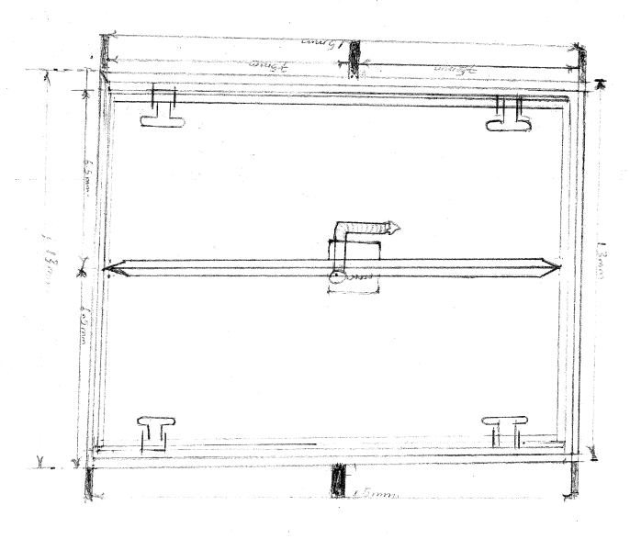
Figure 2.1: Double door

CHAPTER THREE
WORK EXPERIENCE

3.1 Construction of Window Protector

3.1.1 Materials/Tools Used
Burglary-proof panels, welding machine, welding electrodes, protective wear (welding helmet, gloves, safety glasses), clamps or magnets, filler material, protective coating or paint.

3.1.2 Welding Process (Procedure)
- All necessary materials and tools for the welding process were gathered, including the burglary-proof panels, welding machine, welding electrodes, protective gear (welding helmet, gloves, safety glasses), and any additional accessories.
- The surfaces to be welded were cleaned and freed from rust, paint, or any other contaminants.
- The burglary-proof panels were properly aligned to ensure they fit securely together and formed a strong joint. Clamps or magnets were used to hold the panels in place during welding.
- Tack welds were performed at key points along the joint to temporarily secure the panels in place. These tack welds helped prevent the panels from shifting or moving during welding.
- The welding machine was used to perform the main welding passes along the entire length of the joint.
- The appropriate filler material was chosen based on the type of metal being welded and the welding process used.
- After completing the welding process, the welds were inspected for any defects or imperfections.

3.1.3 Finishing
- The welded joints were allowed to cool down gradually to avoid introducing stress or distortion.
- A visual inspection of the welded joints was performed to ensure they met the required quality standards.
- A protective coating or paint was applied to the welded joints to prevent corrosion and enhance the longevity of the burglary-proof structure.

3.1.4 Precautions Observed
- All surfaces to be welded were cleaned thoroughly to remove rust, paint, or any contaminants.
- Proper alignment of the panels was ensured before welding.
- Protective gear, including welding helmets, gloves, and safety glasses, was worn at all times.
- Tack welds were used to prevent movement of the panels during the main welding process.
- Welded joints were allowed to cool gradually to avoid stress or distortion.
- A final inspection was conducted to check for any defects or imperfections in the welds.
- A protective coating or paint was applied to prevent corrosion.
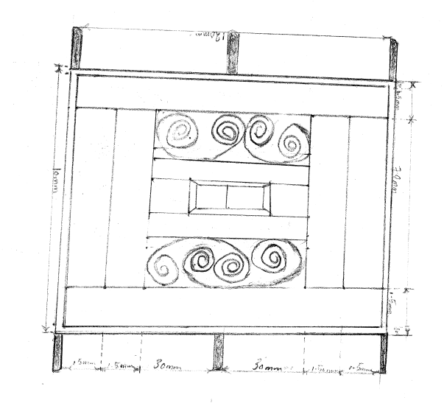
Figure 3.1: Window protector

3.2 Construction of a Door

3.2.1 Materials/Tools Used
Metal door panels, Welding machine, Welding electrodes, Protective wear (welding helmet, gloves, safety glasses), Clamps or magnets, Filler material, Protective coating or paint.

3.2.2 Welding Process (Procedure)
- All necessary materials and tools for the welding process were gathered, including the metal door panels, welding machine, welding electrodes, and protective gear (welding helmet, gloves, safety glasses).
- The surfaces to be welded were cleaned and freed from rust, paint, or any other contaminants.
- The metal door panels were properly aligned to ensure they fit securely together and formed a strong joint. Clamps or magnets were used to hold the panels in place during welding.
- Tack welds were performed at key points along the joint to temporarily secure the panels in place. These tack welds helped prevent the panels from shifting or moving during welding.
- The welding machine was used to perform the main welding passes along the entire length of the joint.
- The appropriate filler material was chosen based on the type of metal being welded and the welding process used.
- After completing the welding process, the welds were inspected for any defects or imperfections.

3.2.3 Finishing
- The welded joints were allowed to cool down gradually to avoid introducing stress or distortion.
- A visual inspection of the welded joints was performed to ensure they met the required quality standards.
- A protective coating or paint was applied to the welded joints to prevent corrosion and enhance the longevity of the metal door.

3.2.4 Precautions Observed
- All surfaces to be welded were cleaned thoroughly to remove rust, paint, or any contaminants.
- Proper alignment of the panels was ensured before welding.
- Protective gear, including welding helmets, gloves, and safety glasses, was worn at all times.
- Tack welds were used to prevent movement of the panels during the main welding process.
- Welded joints were allowed to cool gradually to avoid stress or distortion.
- A final inspection was conducted to check for any defects or imperfections in the welds.
- A protective coating or paint was applied to prevent corrosion.

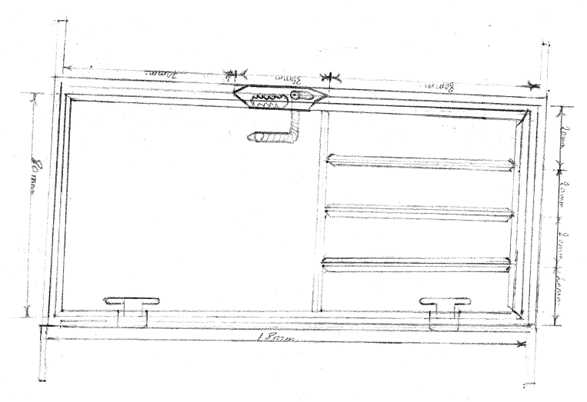
Figure 3.2: Door

3.3 Construction of a Rolling Metal Gate

3.3.1 Material Used
Rolling gate panels, welding machine, welding electrodes, protective wear (welding helmet, gloves, safety glasses), rollers, tracks, clamps or magnets, filler material, protective coating or paint.

3.3.2 Welding Process (Procedure)
- All necessary materials and tools for the welding process were gathered, including the rolling gate panels, welding machine, welding electrodes, protective gear (welding helmet, gloves, safety glasses), rollers, tracks, and any additional accessories.
- The surfaces to be welded were cleaned and freed from rust, paint, or any other contaminants.
- The metal panels and frame components were properly aligned to ensure they fit securely together and formed a strong joint. Clamps or magnets were used to hold the panels in place during welding.
- Tack welds were performed at key points along the joints to temporarily secure the panels and frame components in place. These tack welds helped prevent the parts from shifting or moving during welding.
- The welding machine was used to perform the main welding passes along the entire length of the joints.
- The appropriate filler material was chosen based on the type of metal being welded and the welding process used.
- After completing the welding process, the welds were inspected for any defects or imperfections.
- The welded joints were allowed to cool down gradually to avoid introducing stress or distortion.
- Rollers were attached to the bottom of the gate, ensuring they were securely fastened and aligned properly with the tracks.
- The tracks were installed, ensuring they were level and securely attached to the supporting structure.
- The rolling gate was mounted onto the tracks, and its movement was tested to ensure smooth operation.

3.3.3 Finishing
- A visual inspection of the welded joints and the entire gate assembly was performed to ensure they met the required quality standards.
- A protective coating or paint was applied to the welded joints and the entire gate to prevent corrosion and enhance the longevity of the rolling metal gate.

3.3.4 Precautions Observed
- All surfaces to be welded were cleaned thoroughly to remove rust, paint, or any contaminants.
- Proper alignment of the panels and frame components was ensured before welding.
- Protective gear, including welding helmets, gloves, and safety glasses, was worn at all times.
- Tack welds were used to prevent movement of the panels and frame components during the main welding process.
- Welded joints were allowed to cool gradually to avoid stress or distortion.
- Rollers and tracks were securely fastened and aligned to ensure smooth operation.
- A final inspection was conducted to check for any defects or imperfections in the welds and overall gate assembly.
- A protective coating or paint was applied to prevent corrosion.
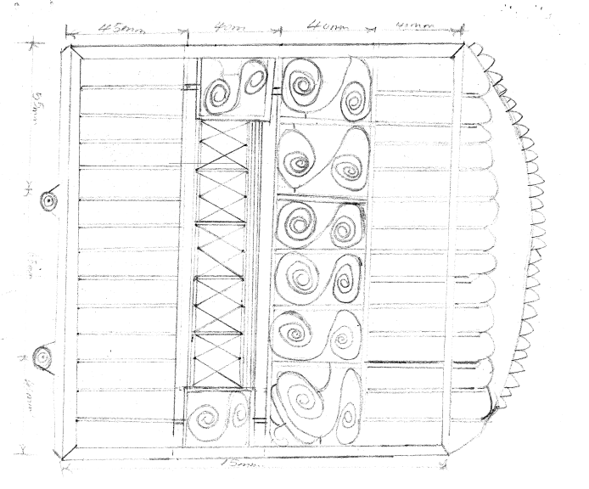
Figure 3.3: Rolling gate

CHAPTER FOUR

CONCLUSION AND RECOMMENDATION

4.1 Conclusion
This report documented the comprehensive work experience involved in the construction of various metal structures, including a double door, window protector, metal door, and rolling metal gate. Each project highlighted the significance of proper materials, tools, and procedures essential for effective fabrication. The meticulous welding processes followed ensured strong and reliable joints, while the finishing techniques applied enhanced durability and aesthetic appeal.
Throughout the projects, strict adherence to safety precautions was observed, emphasizing the importance of protective gear and clean working conditions. The combination of theoretical knowledge and practical application not only bridged the gap between education and industry but also equipped students with invaluable skills relevant to their future careers. Overall, these experiences underscored the importance of quality craftsmanship and the role of industrial training in preparing students for the workforce.

4.2 Recommendations
Students often face challenges during their SIWES (Student Industrial Work Experience Scheme). To address this, it is recommended that the organization where the student undertakes SIWES provides an allowance to support them financially.
Additionally, the Industrial Training Fund (ITF) should ensure prompt payment of allowances once students complete their industrial training.
The institution should strive to establish connections with various companies to facilitate the placement of students during their SIWES period. This will help in evenly distributing students across different organizations, enhancing their learning experience.
Regular check-ins and evaluations should be conducted to ensure that the students are gaining practical and relevant experience.
Furthermore, the institution itself should provide consistent supervision, offering guidance and support to the students throughout their industrial training. This dual supervision will ensure a comprehensive and beneficial SIWES experience for all students.

REFERENCES
Chapman, W. (2020). Work shop technology. Published by Hodder Headline Group
Chiang, CK (2017). "Transport and optical properties of polythiazyl bromides: (SNBr0.4)x". Solid State Communications. 23 (9): 607–612
Green, J. N. (2013). Introduction to Technical Drawing: Metal work theory for school certificate and GCE, McGraw Hill, New York.
Kittel, C. (2018). Introduction to solid state physics. Paul McEuen (Global edition, [9th edition] ed.). Hoboken, NJ: Wiley. ISBN 978-1-119-45416-8.

